37.68: The baseball had better be moving non-relativistically, so the Doppler shift formula (Eq. (37.25)) becomes 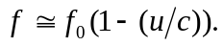 In the baseball’s frame, this is the frequency with which the radar waves strike the baseball, and the baseball reradiates at f. But in the coach’s frame, the reflected waves are Doppler shifted again, so the detected frequency is and the fractional frequency shift is 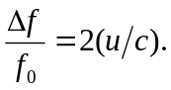 In this case,
